GYM HUB

Smart Gym Management System using MongoDB, Express.js, Node.js and JavaScript

1. Abstract
Gym Hub is a full-stack web application developed to simplify gym management operations. The system enables administrators to manage members, trainers, membership plans, workout programs, and enrollments through a centralized dashboard. The application uses MongoDB as the database, Express.js and Node.js for backend API development, and HTML, CSS, and JavaScript for the frontend.
The project demonstrates CRUD operations, RESTful API development, MongoDB document modeling, relationship management using ObjectId references, and frontend-backend integration through Fetch API.

2. Objectives
- Manage gym members efficiently.
- Manage trainer information.
- Create and maintain membership plans.
- Create workout programs and assign trainers.
- Enroll members into workout programs and plans.
- Demonstrate MongoDB relationships using references and populate().
- Implement CRUD operations using REST APIs.

3. Technology Stack

Frontend
- HTML5
- CSS3
- JavaScript

Backend
- Node.js
- Express.js

Database
- MongoDB
- MongoDB Compass

API Testing
- Postman

4. Methodology

Phase 1: Requirement Analysis
Requirements for gym management were identified including member management, trainer management, workout programs, membership plans, and enrollments.

Phase 2: Database Design
MongoDB collections were designed using Mongoose schemas.
Collections:
- Members
- Trainers
- Membership Plans
- Workout Programs
- Enrollments

Phase 3: Backend Development
RESTful APIs were created using Express.js.
Implemented operations:
- Create
- Read
- Update
- Delete

Phase 4: Relationship Mapping
MongoDB ObjectId references were used to establish relationships.
Examples:
- Workout Program → Trainer
- Enrollment → Member
- Enrollment → Membership Plan
- Enrollment → Workout Program

Phase 5: Frontend Development
A dashboard-based interface was developed to interact with backend APIs using Fetch API.

Phase 6: Testing
All endpoints were tested using Postman and verified using MongoDB Compass.

5. System Architecture
Frontend (HTML/CSS/JS)
↓
Fetch API Requests
↓
Express.js Routes
↓
Mongoose Models
↓
MongoDB Database

6. Database Collections

Member
Fields:
- Name
- Email
- Phone
- Age

Trainer
Fields:
- Name
- Specialization
- Experience

Membership Plan
Fields:
- Plan Name
- Duration
- Price

Workout Program
Fields:
- Program Name
- Duration
- Trainer ID (Reference)

Enrollment
Fields:
- Member ID (Reference)
- Plan ID (Reference)
- Program ID (Reference)
- Enrollment Date

7. Features Implemented

Member Management
- Add Member
- View Members
- Delete Member
- Update Member (via Postman)

Trainer Management
- Add Trainer
- View Trainers
- Delete Trainer
- Update Trainer (via Postman)

Membership Plan Management
- Add Plan
- View Plans
- Delete Plan
- Update Plan (via Postman)

Workout Program Management
- Add Program
- View Programs
- Delete Program
- Update Program (via Postman)
- Trainer Selection using Dropdown
- Trainer Information using populate()

Enrollment Management
- Add Enrollment
- View Enrollments
- Delete Enrollment
- Update Enrollment (via Postman)
- Member, Plan and Program References

8. API Endpoints

Members
GET /members
POST /members
PUT /members/:id
DELETE /members/:id

Trainers
GET /trainers
POST /trainers
PUT /trainers/:id
DELETE /trainers/:id

Plans
GET /plans
POST /plans
PUT /plans/:id
DELETE /plans/:id

Programs
GET /programs
POST /programs
PUT /programs/:id
DELETE /programs/:id

Enrollments
GET /enrollments
POST /enrollments
PUT /enrollments/:id
DELETE /enrollments/:id

9. Testing and Verification
Testing was performed using:
- Postman for API verification
- MongoDB Compass for database verification
- Browser interface for frontend verification

Steps and Screenshot Verification:
Steps :
- Go to the folder using in the terminal
- Run node app.js to start the backend also note that you need to connect to the 27017 port and create a db called smartgymdb in MongoDB
- Go to browser and open “localhost:5000/#”
- Now the frontend is running.
- We can Insert, View and Delete using the frontend
- While Update using the Frontend was a bit too much code so I didn’t implement it.. Update is done using postman and verified with the backend..
App.js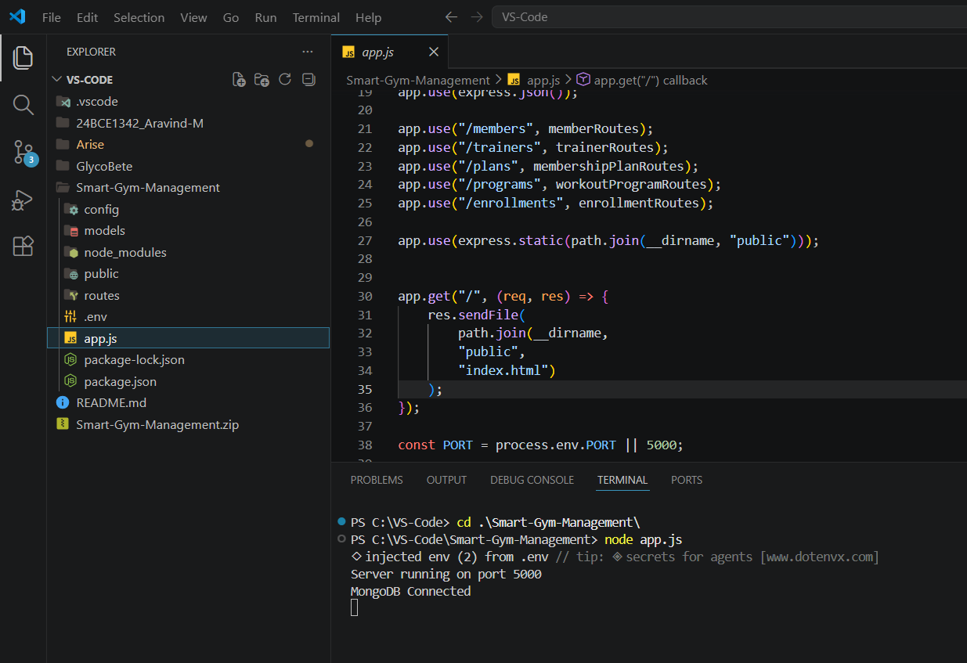
Home Screen – Landing page
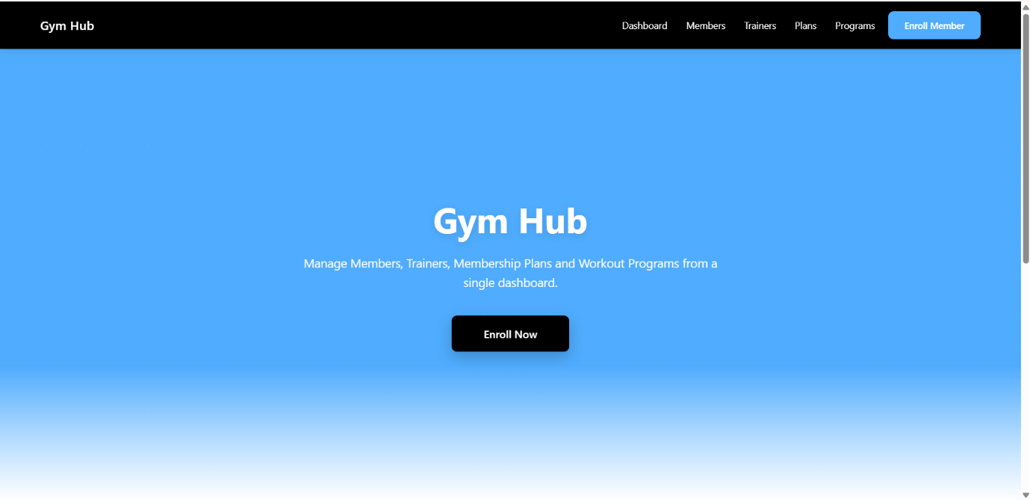
The Features Cards – On click opens the menu where we can see data and add/ Delete Them
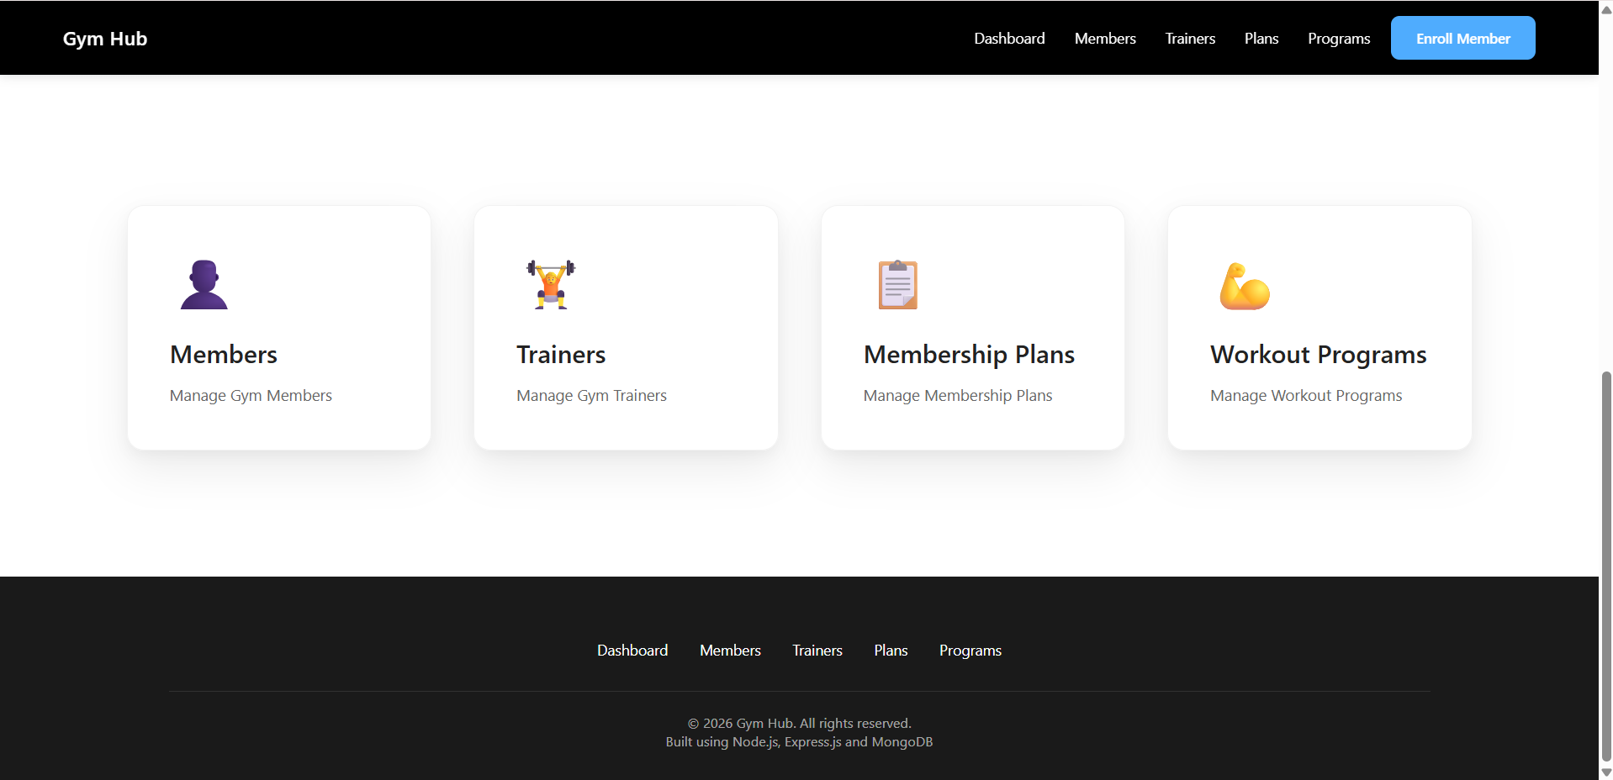
When clicked on the member Card : We can see all the members and Add new +
The delete button can be used to delete the members….
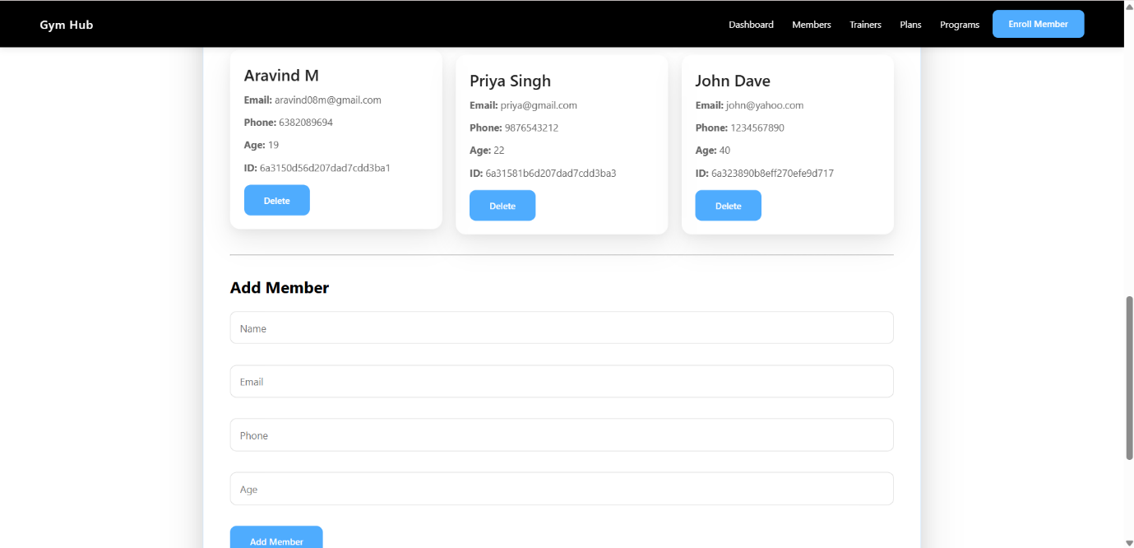
Adding a new member :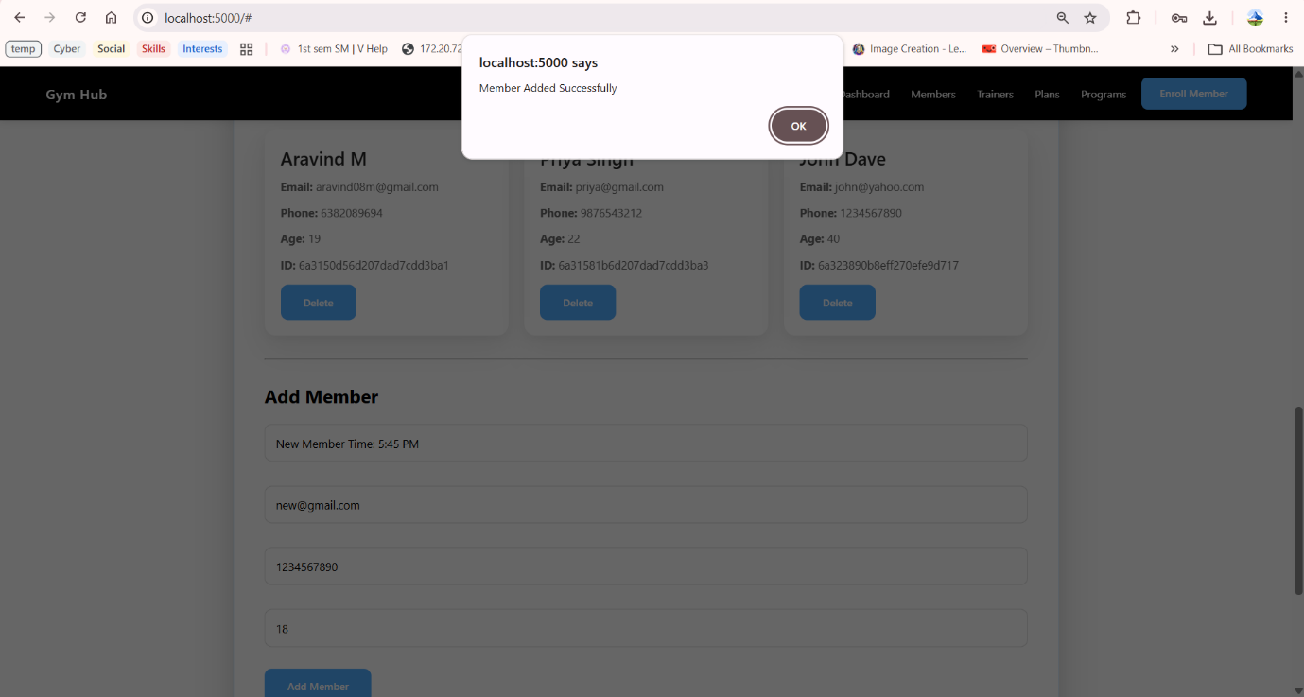
After adding New member:
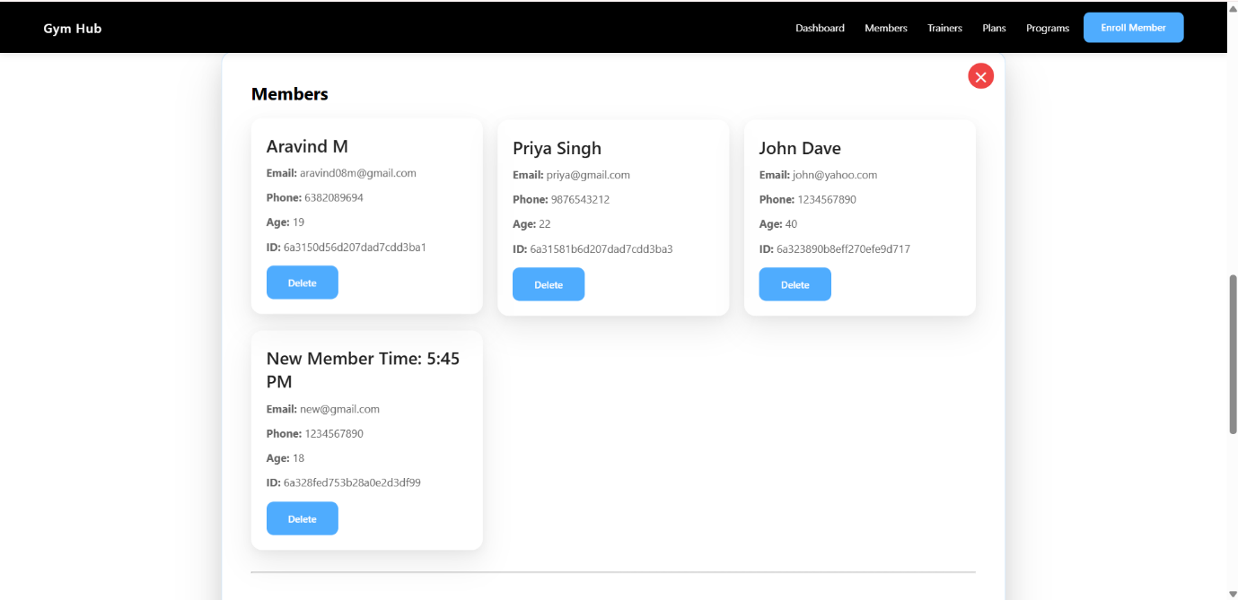
Trainer Card Clicked – same layout (add/delete)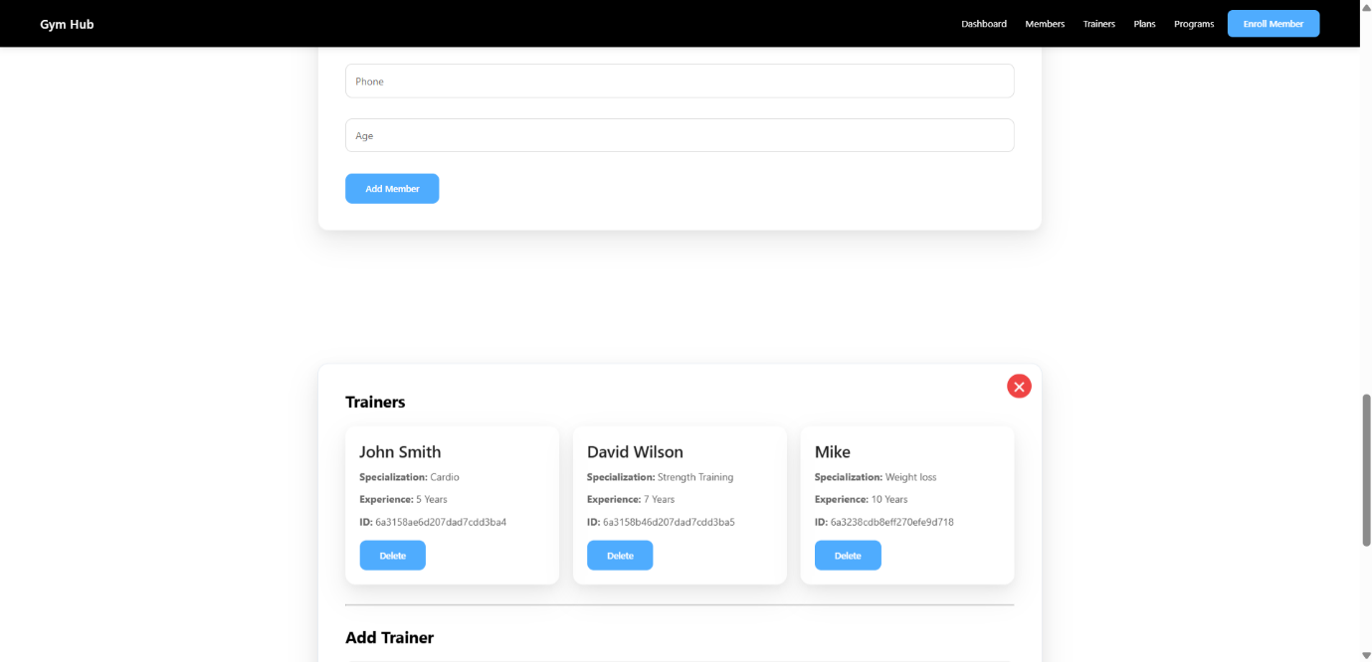Trainer added:
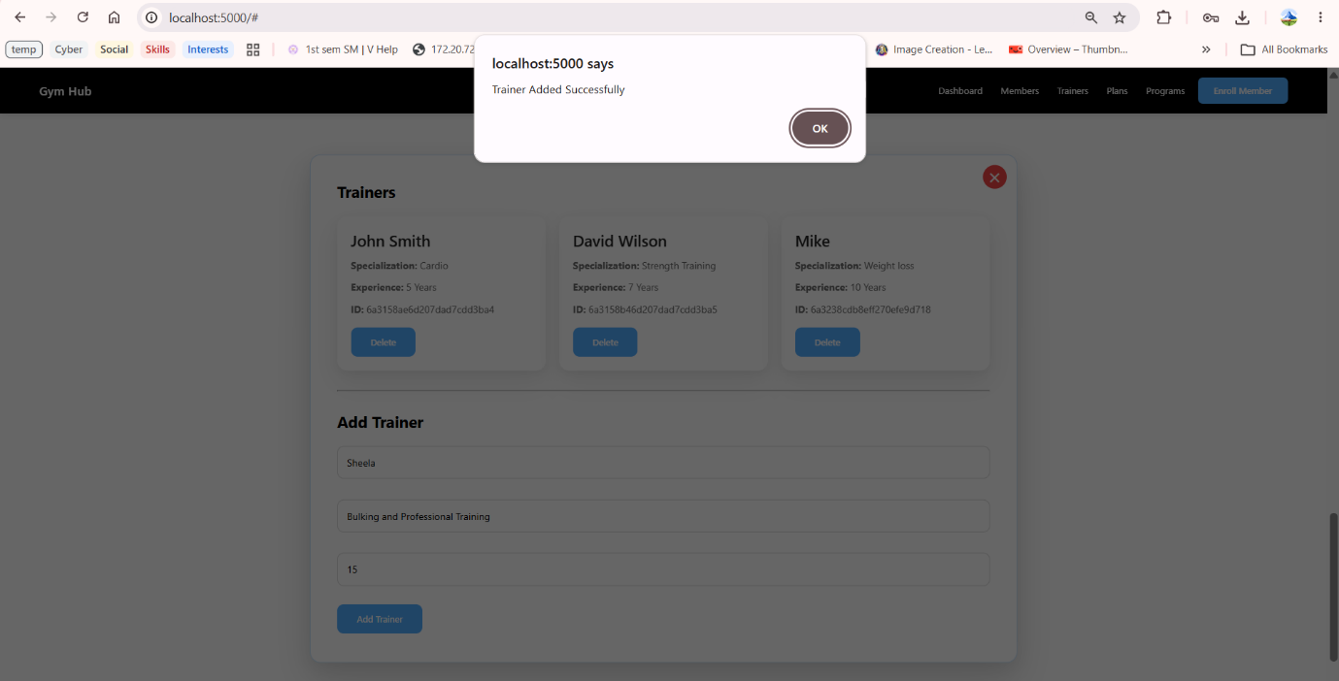
After Adding new Trainer :
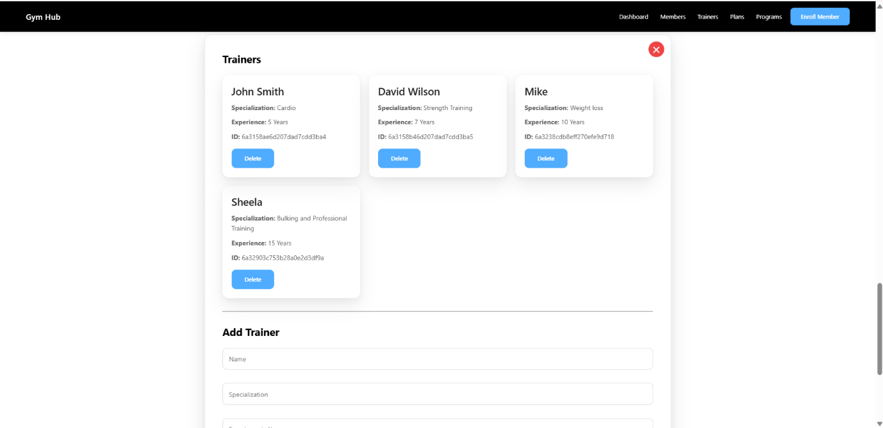
Adding a New Workout plan:
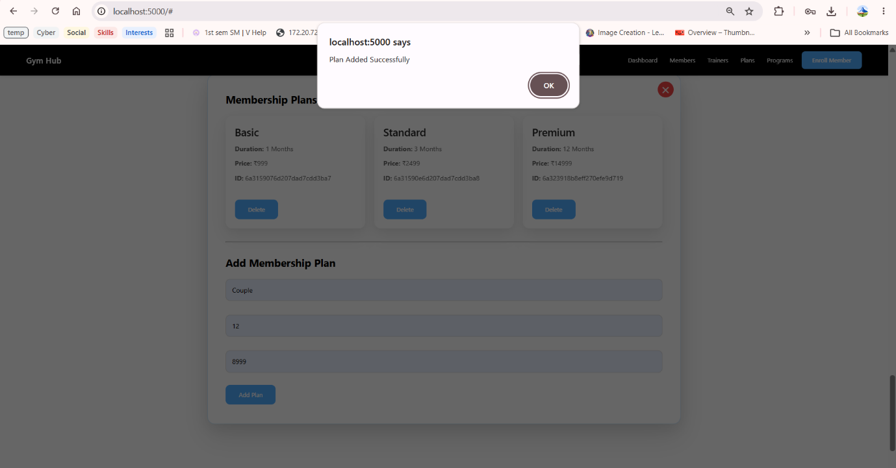
After adding New plan :
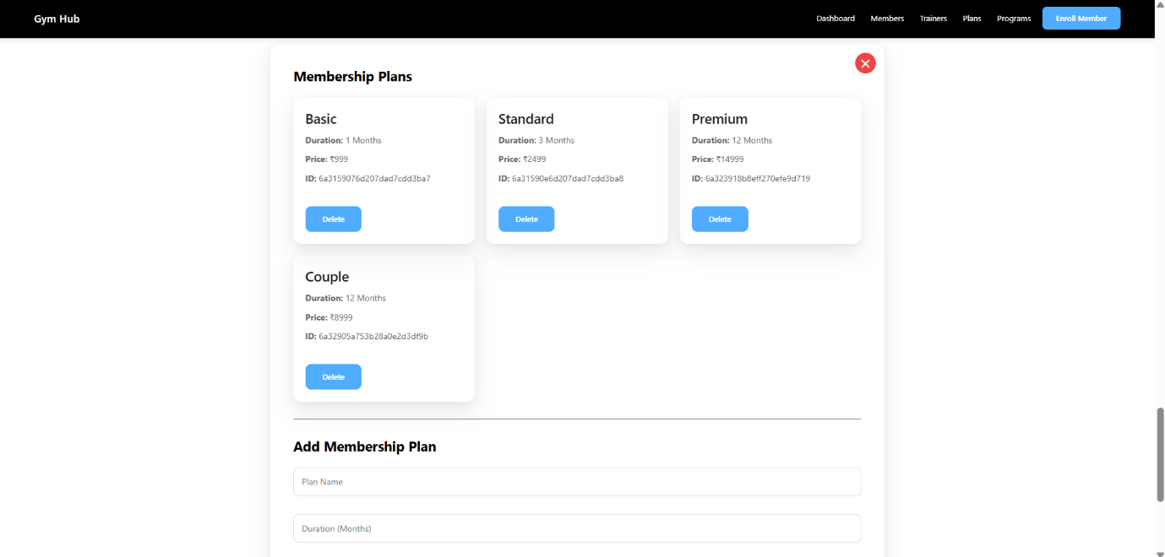

Workout programs – also I have added a drop down menu as we need to enter the product so I used POPULATE to get the id in a drop down menu…(Also auto update as we enter new)

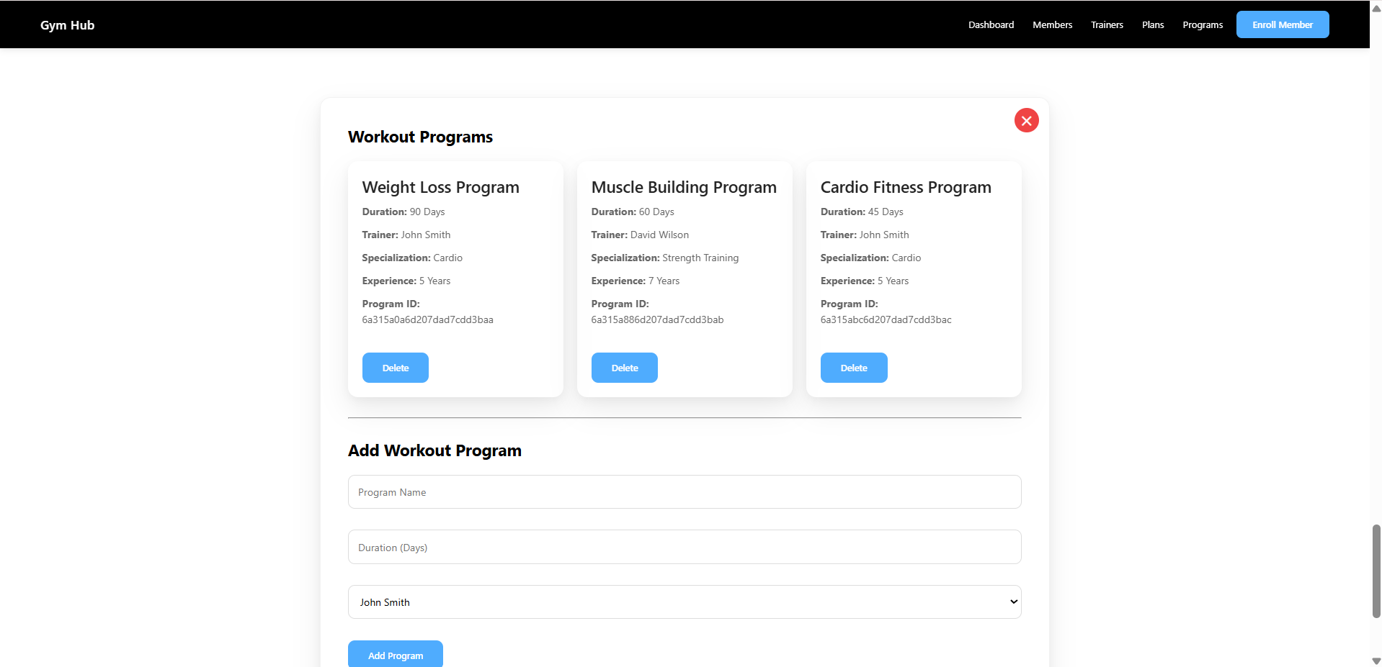
Enrolments fully need dropdowns as everything needs Ids
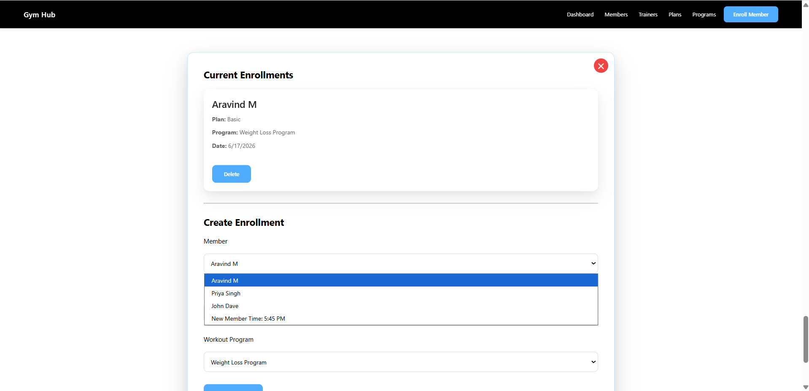
We can Add and delete enrolments as well ..
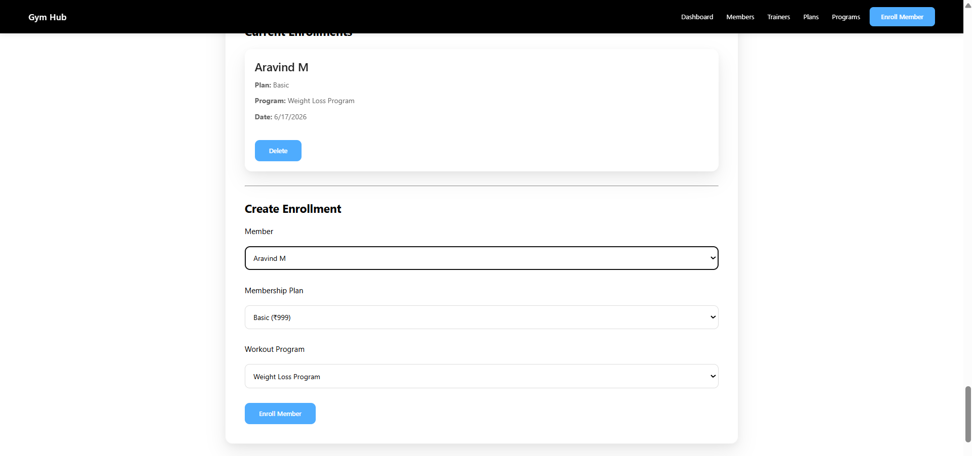

Deleting Records Require confirmation from the user and once delete it would disappear from the cards automatically …
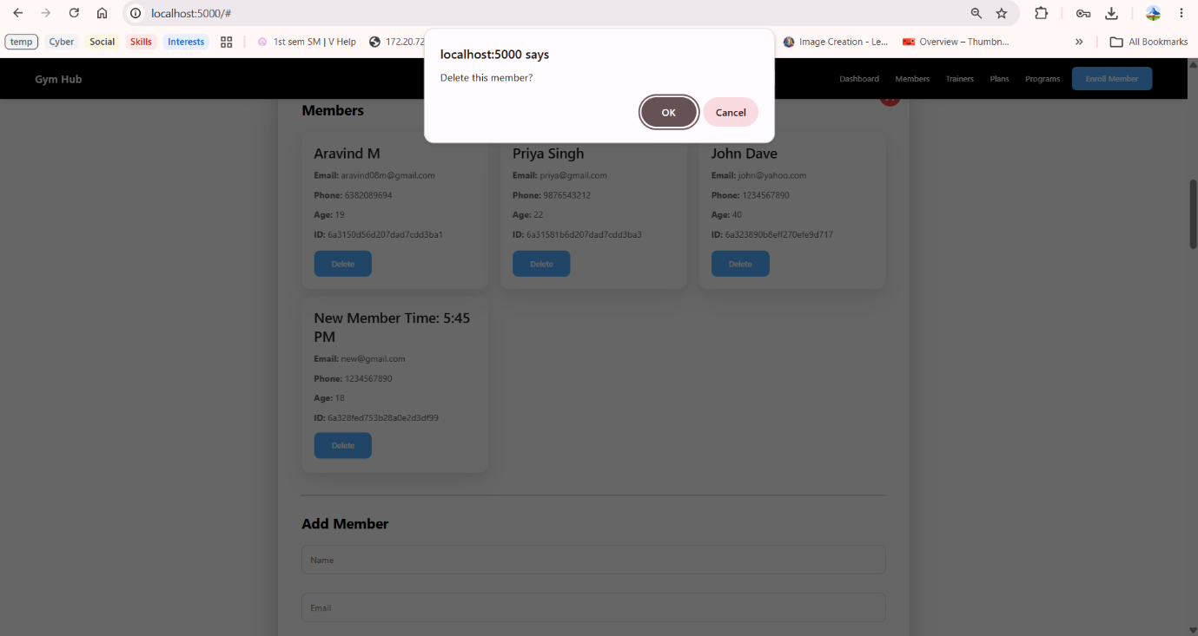
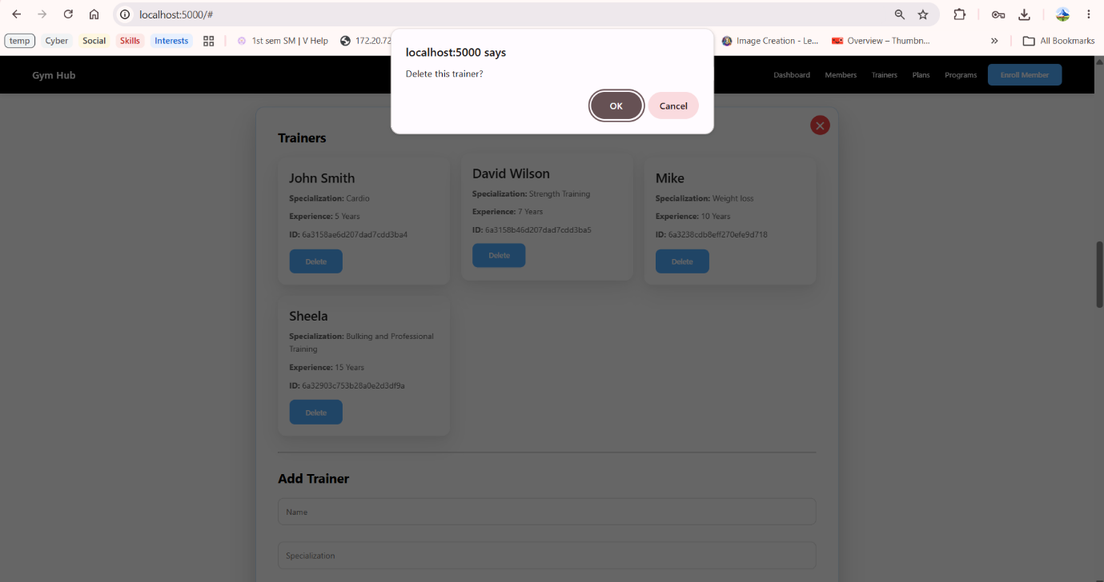

After Deleting of the records .. auto updated the cards ..
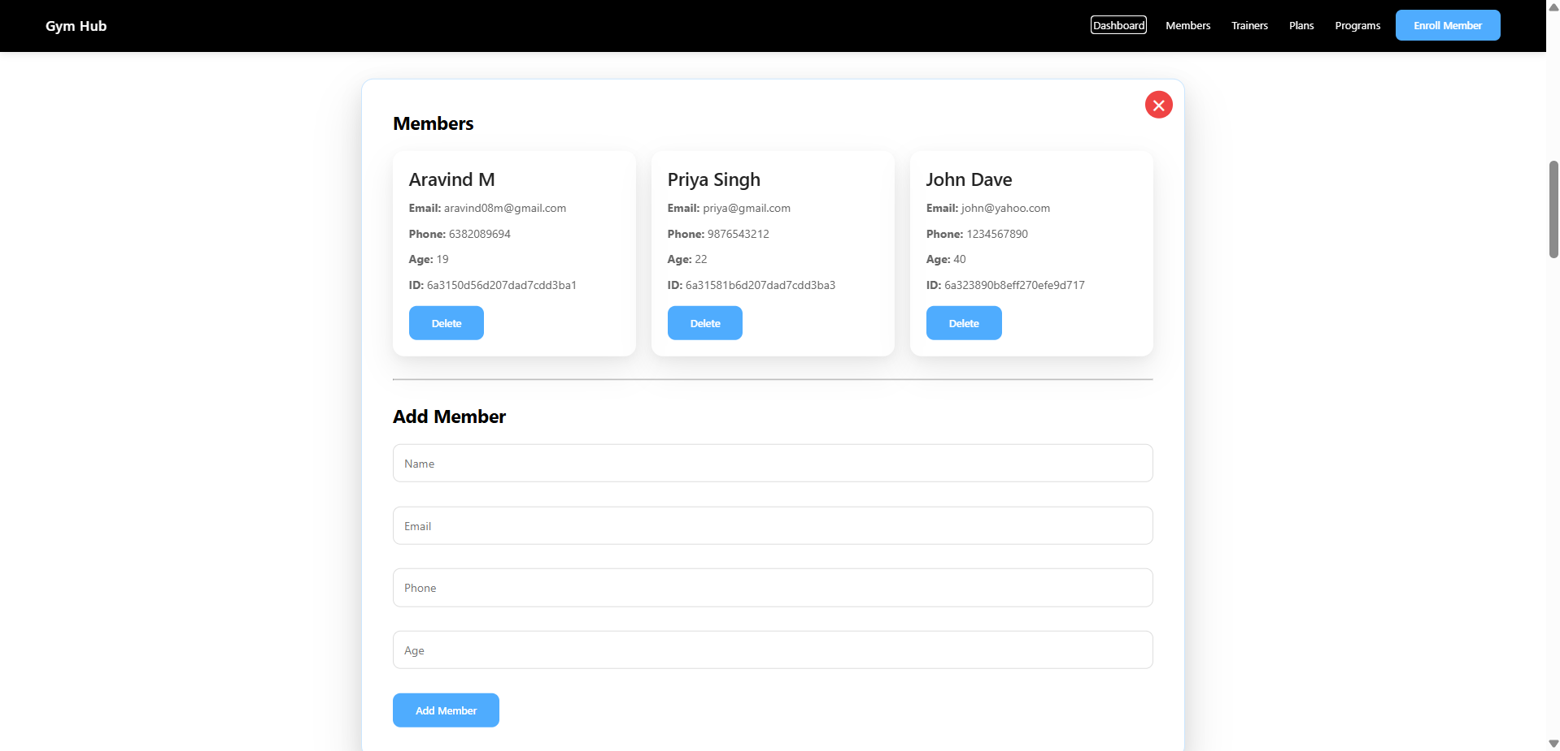
Update Didn’t implement in the Website as frontend was complicated… :

Update done using PostMan:
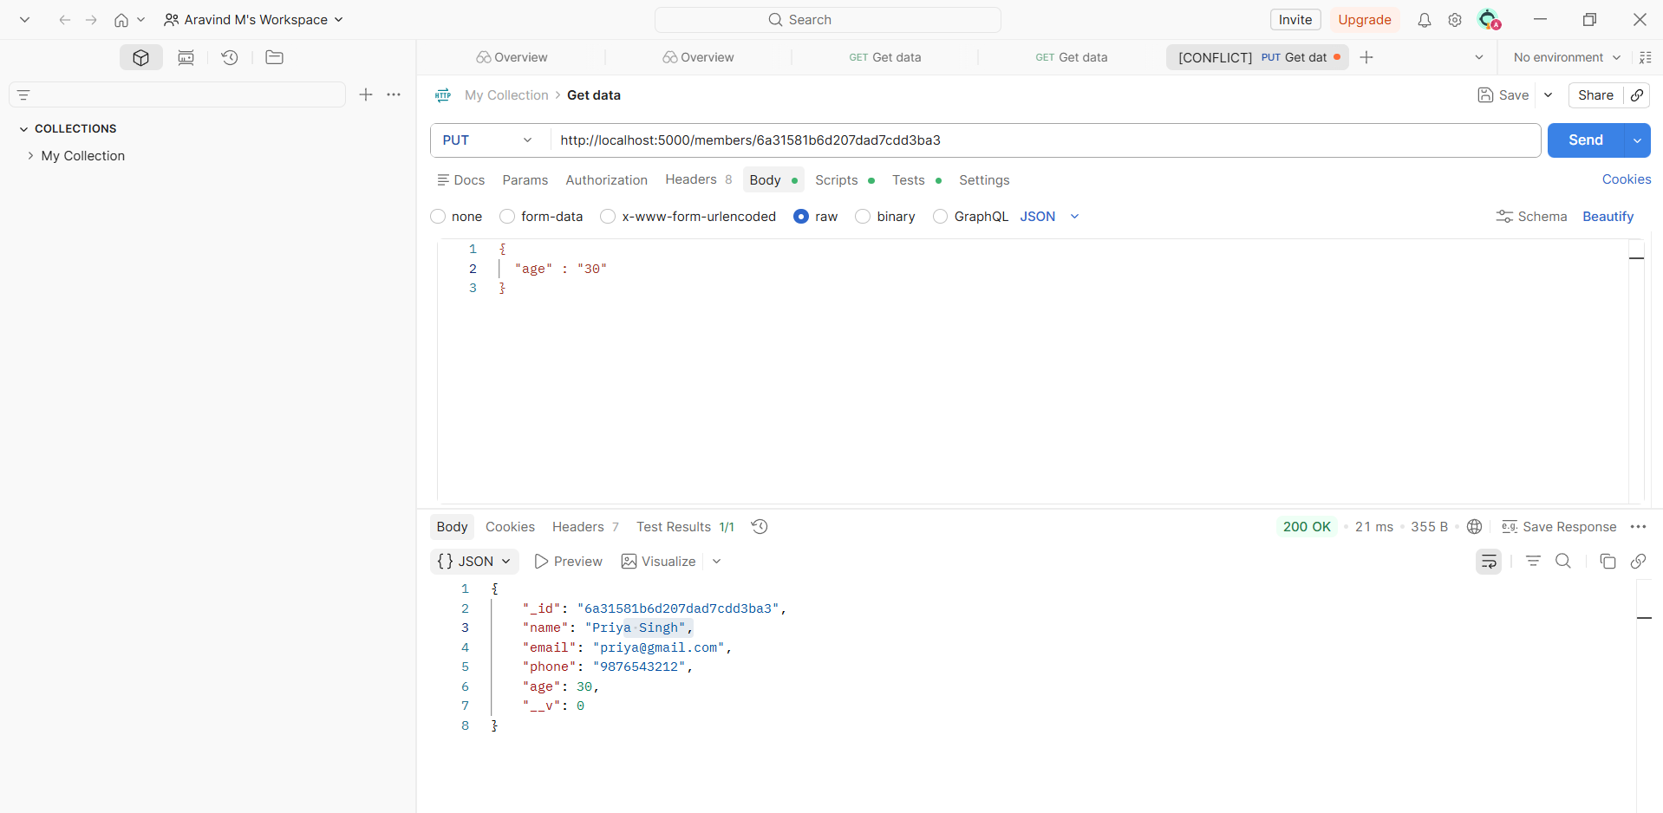
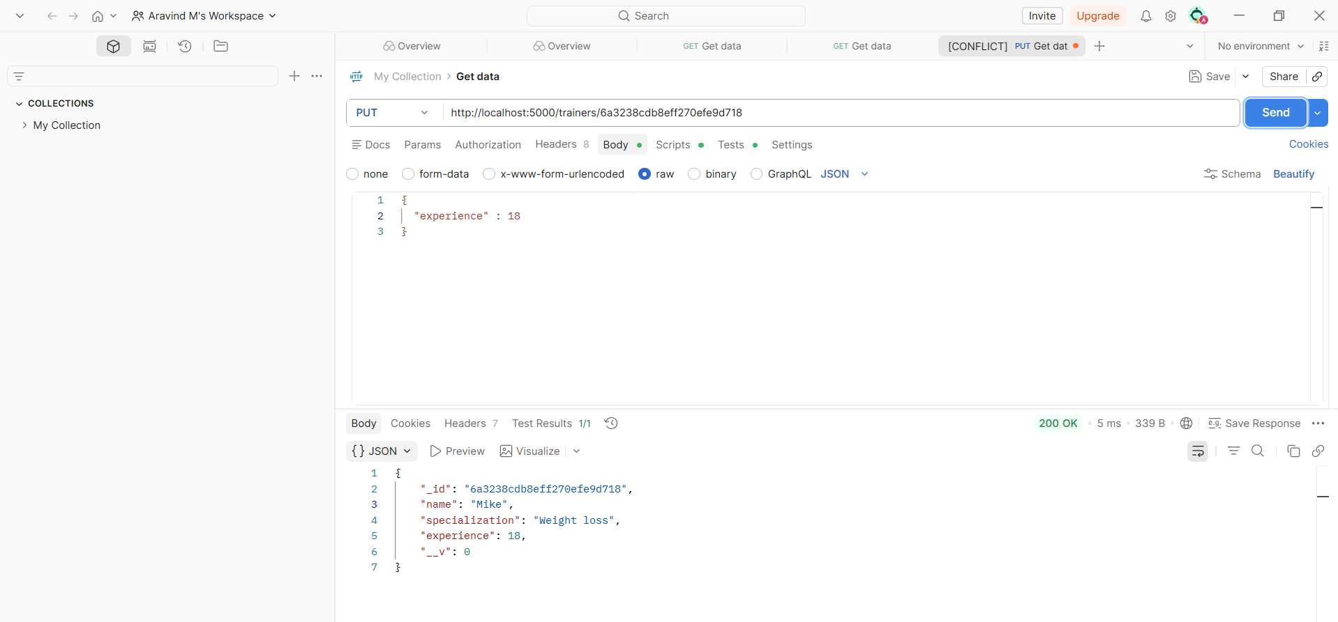
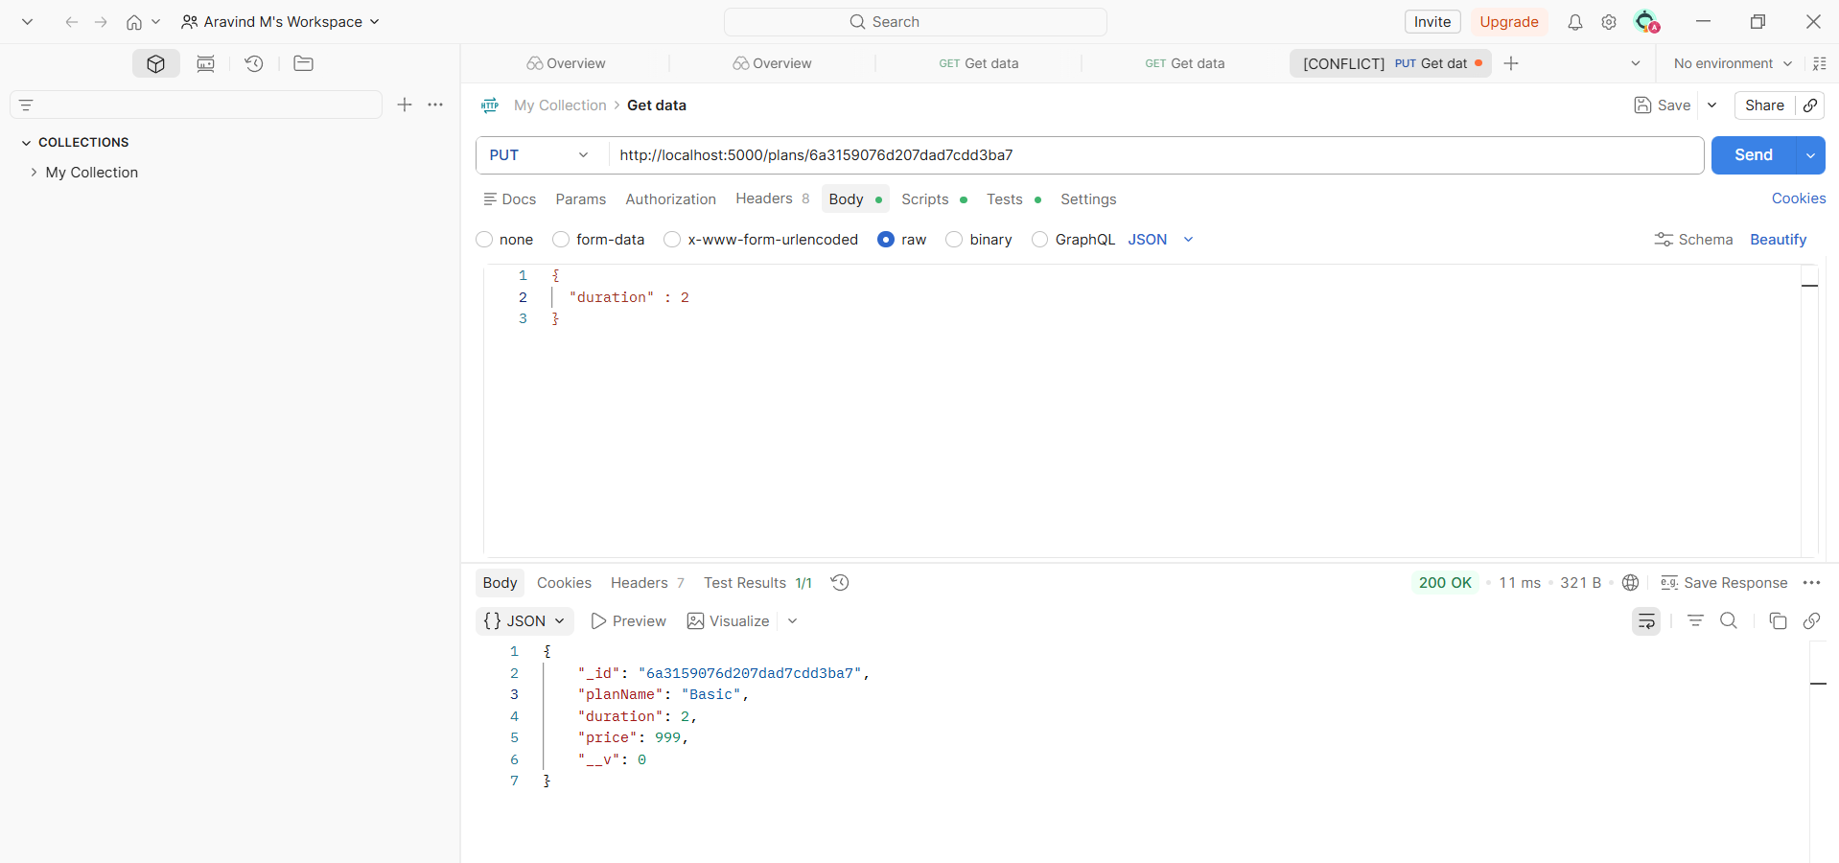
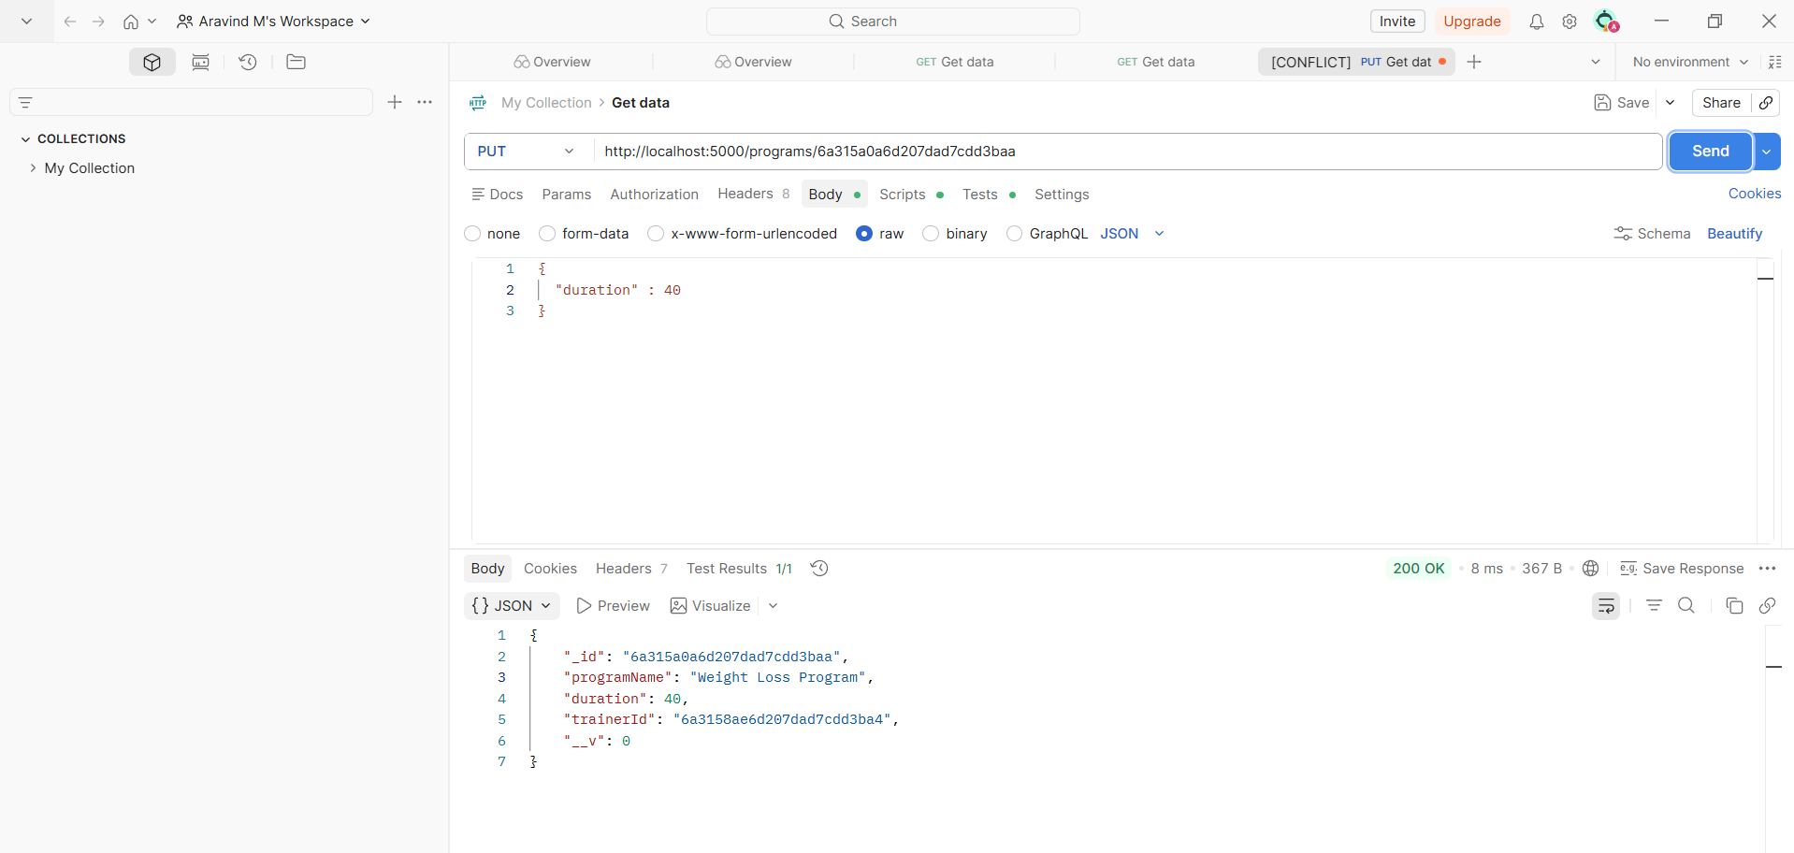
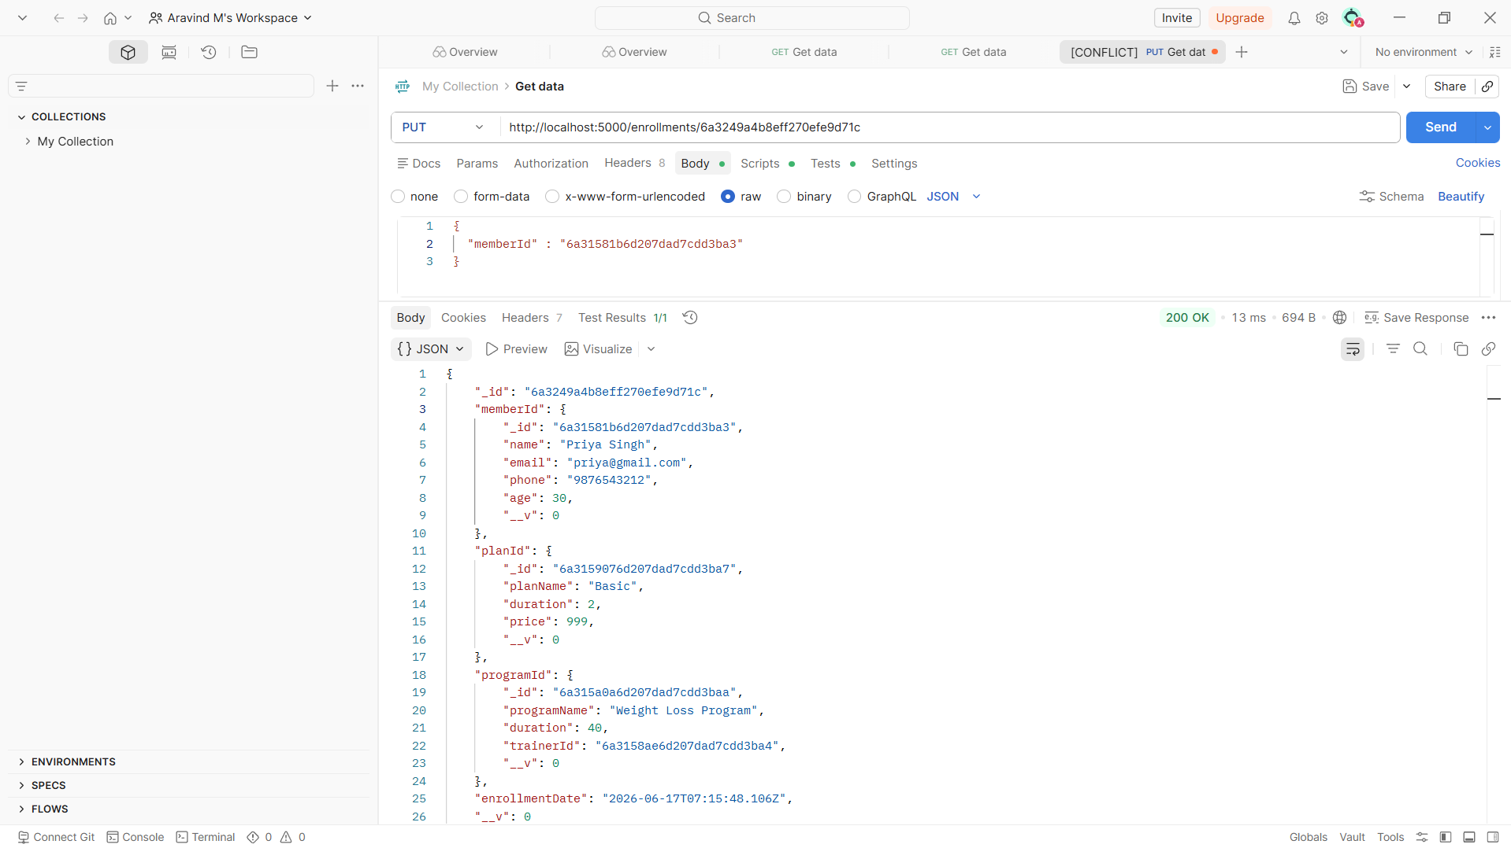

Compass For verification:

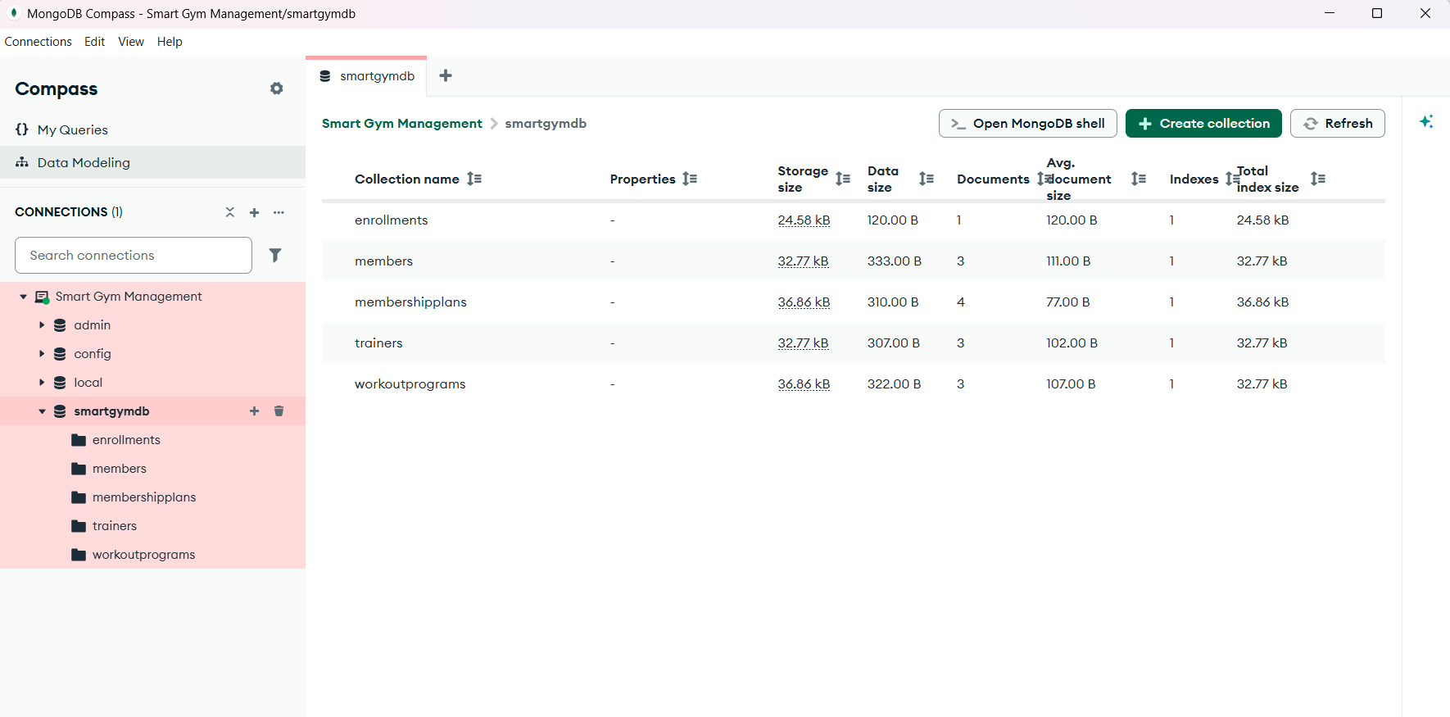
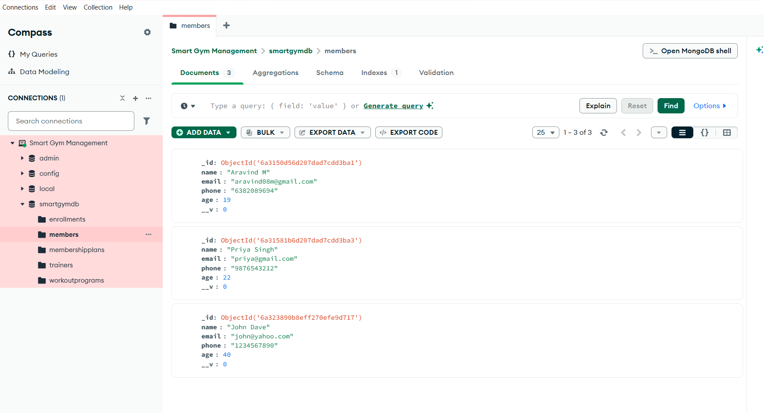
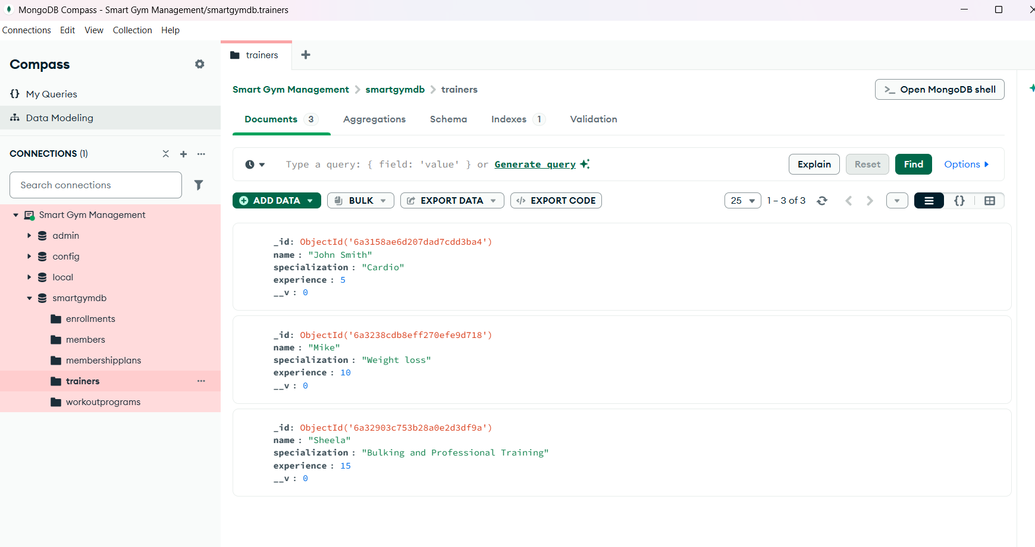
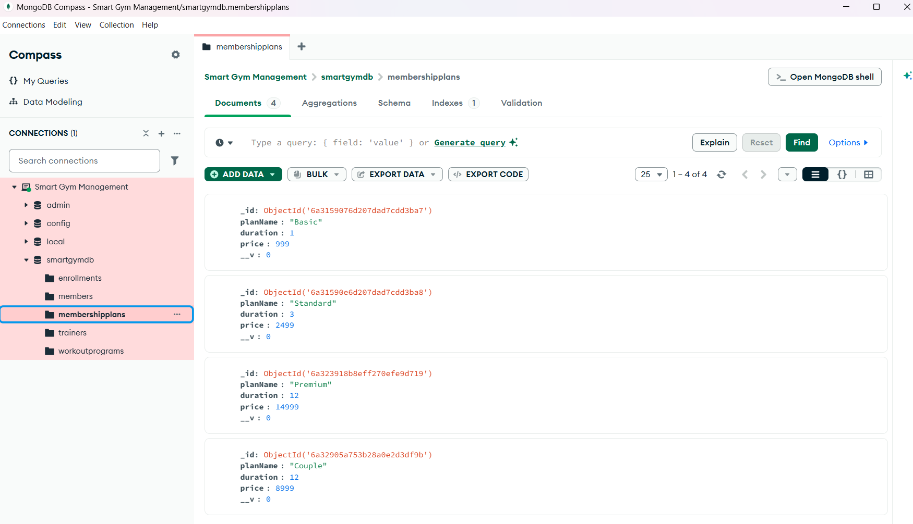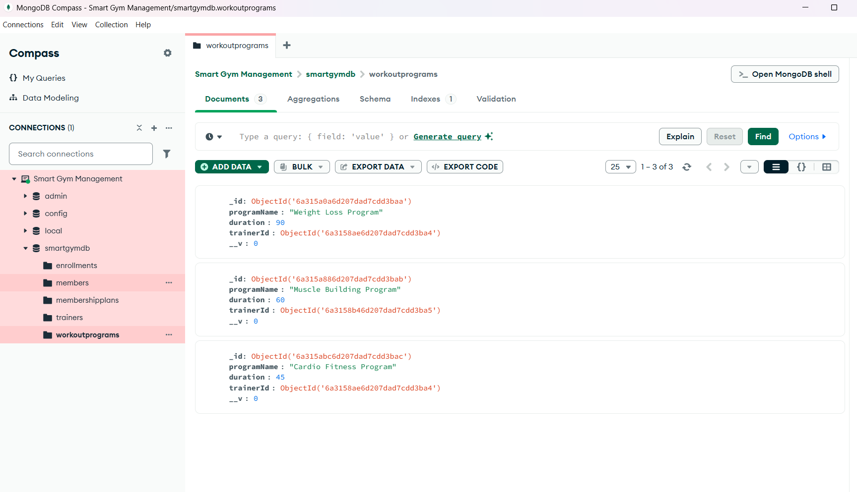
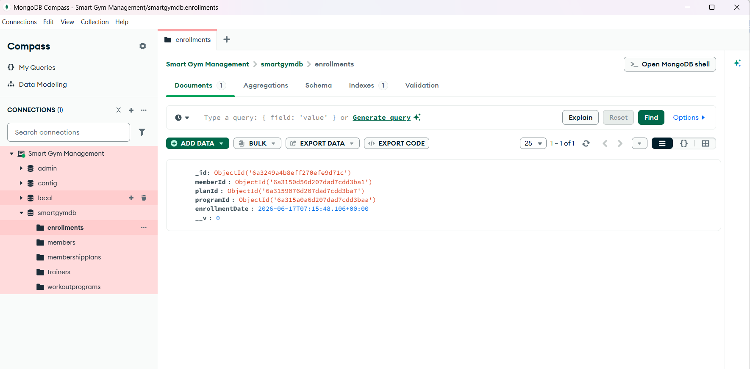

10. Results
The Gym Hub system successfully performs:
- Member Management
- Trainer Management
- Membership Management
- Workout Program Management
- Enrollment Management
- MongoDB Relationship Handling
- CRUD Operations
The frontend dynamically updates data after creation and deletion operations, ensuring real-time synchronization with the database.

11. Future Enhancements
- Frontend Update Functionality
- Authentication and Authorization
- Role-Based Access Control
- Payment Integration
- Attendance Tracking
- Progress Monitoring
- Email Notifications

12. Conclusion
Gym Hub successfully demonstrates a complete gym management solution using the MERN-style backend architecture with MongoDB, Express.js, and Node.js. The project showcases CRUD operations, database relationships, API development, and frontend integration while providing a scalable foundation for future enhancements.

